DEPARTMENT OF ELECTRONICS AND
COMMUNICATION ENGINEERING
ELECTRONICS WORKSHOP-II


EC106
Project Synopsis
Submitted by: Submitted To:
PROJECT SYNOPSIS: Path Finder / Obstacle Avoiding Car using Arduino

1. Introduction
The Obstacle Avoiding Robot is an intelligent vehicle that can autonomously navigate its environment without human intervention. The primary objective of this project is to build a robotic car that detects obstacles in its path using ultrasonic waves and automatically redirects itself to an open, collision-free path. This technology forms the foundational basis for modern autonomous vehicles, warehouse automation robots, and planetary rovers.

2. Components Used and Detailed Descriptions
Arduino Uno R3 (The Brain): A microcontroller board based on the ATmega328P. It acts as the central processing unit of the car, reading data from the sensors, processing the logic, and sending commands to the motor driver.
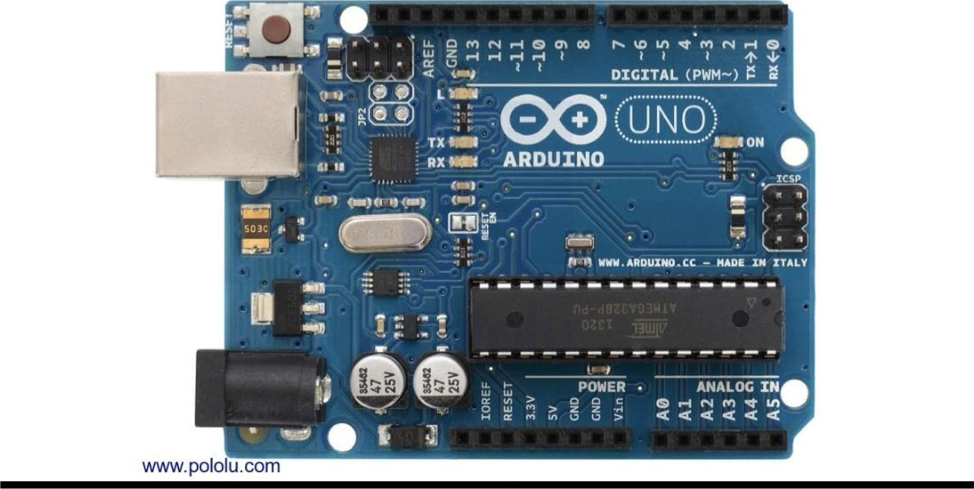
HC-SR04 Ultrasonic Sensors (The Eyes - 3 Units used): These sensors calculate distance by emitting ultrasonic sound waves (at 40,000 Hz) from the Trigger pin and waiting for the echo to bounce back to the Echo pin. By calculating the time it takes for the sound to return, the
Arduino determines the exact distance of an obstacle. Using three sensors (Left, Front, and Right) allows the car to "see" a 180-degree view.
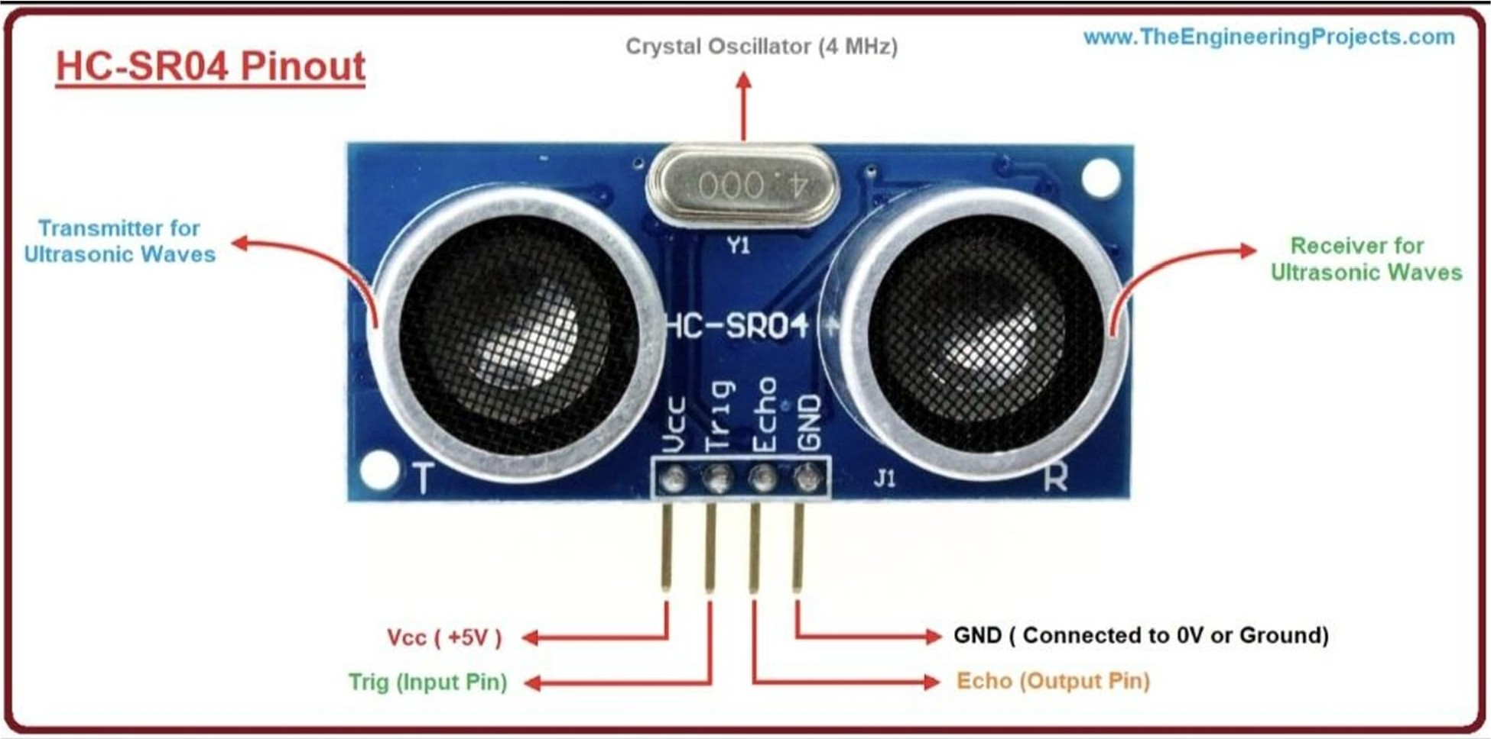
L298N Dual H-Bridge Motor Driver (The Muscle): The Arduino cannot provide enough current to drive the motors directly. The L298N module takes the low-current control signals from the Arduino (via pins INI, IN2, IN3, IN4) and uses the high current from the battery to drive the motors forward or backward.
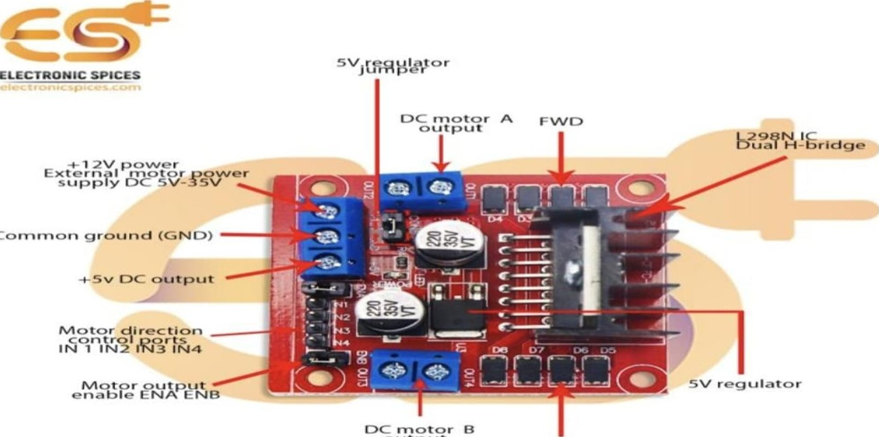
Cornroor-•
output

FVVD

DC Gear Motors (BO Motors) & 4WD Chassis: Battery Operated (BO) motors are DC motors with an attached gearbox to reduce speed and increase torque, allowing the car to carry its own weight. The acrylic chassis holds all components together. (Note: Though it's a 4-wheel drive chassis, the motors on the same side are usually wired together in parallel so they act as two distinct left/right tracks).
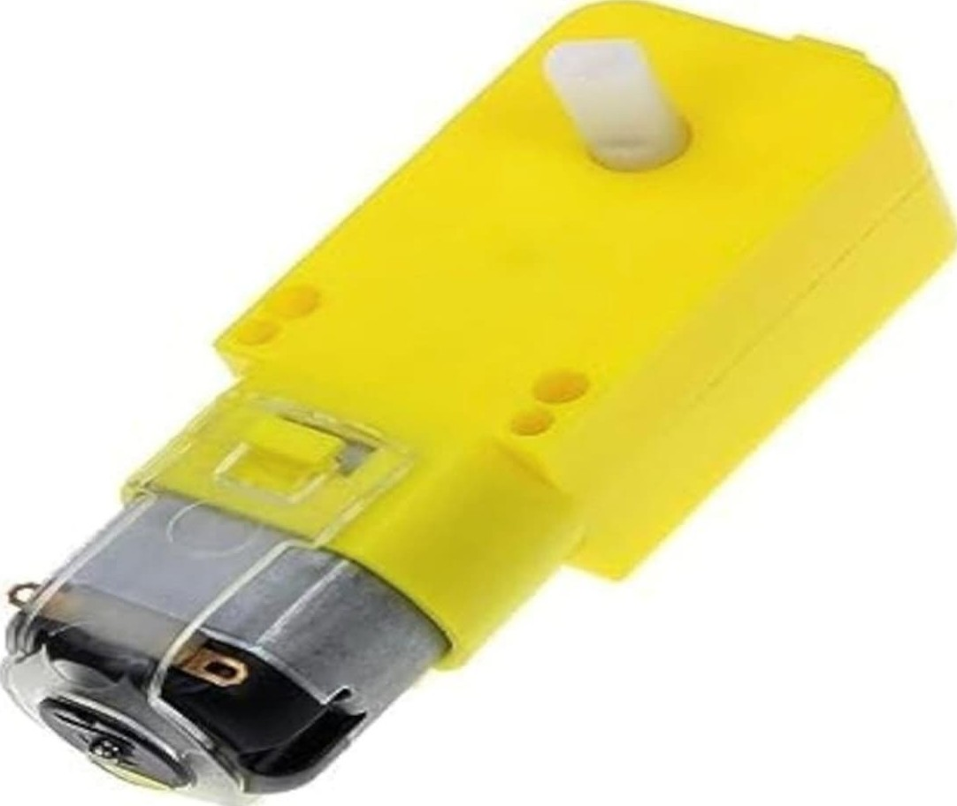
18650 Li-ion Batteries & Holder (Power Supply): Two 3.7V 18650 batteries in series provide ^{N}7.4v of power. This is perfect for powering the L298N motor driver, which in turn regulates a 5V supply to power the Arduino and the sensors.
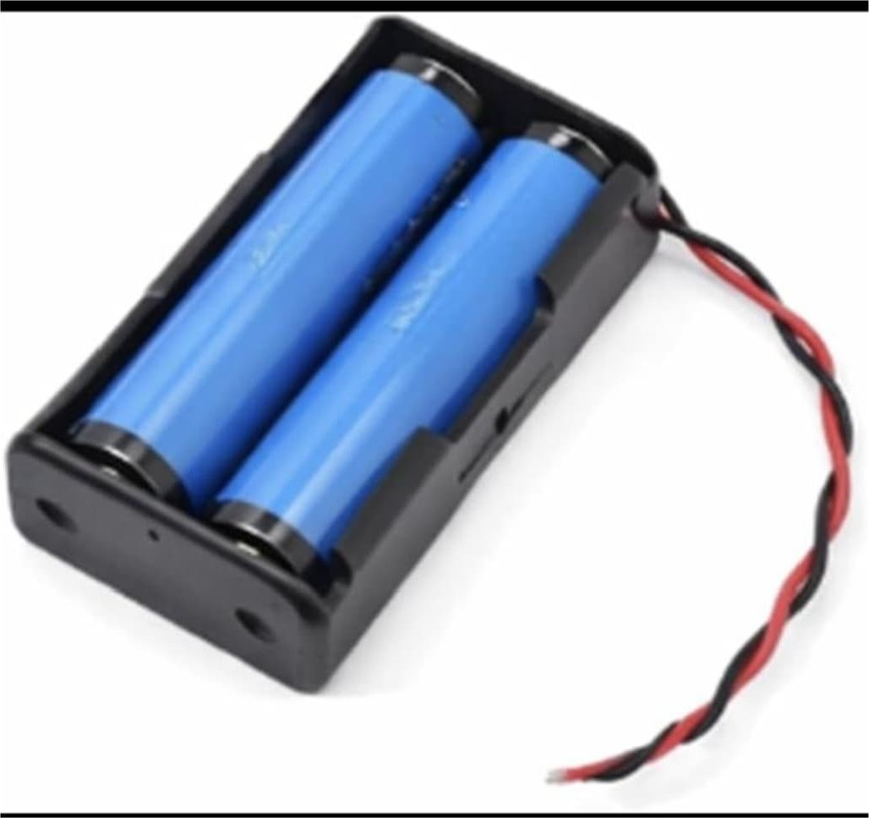
Jumper Wires & Breadboard: Used to establish connections between components. The breadboard is specifically used to distribute the common 5V (VCC) and Ground (GND) lines to the three separate ultrasonic sensors.
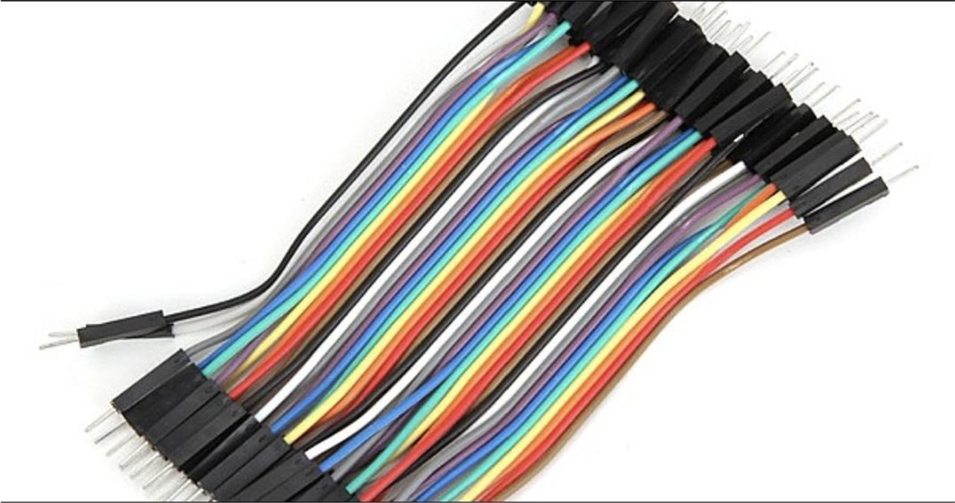
4WD Smart Robot Car Chassis Kit:Acrylic Base: The clear plastic "skeleton" of the car. It features pre-cut holes and slots for easily mounting your Arduino, L298N motor driver, and sensors.
4x BO Motors (Gear Motors): The yellow components driving the wheels. They contain internal gears to provide enough torque (pulling power) to move the car's weight. To steer, you will wire the left two motors together and the right two motors together so it can turn like a tank.
Rubber Wheels: Push-fitted onto the motors to provide traction on the floor.
Speed Encoder Disks: The small, black, slotted disks visible on the inner motor shafts. If you add optical sensors later, these slots allow the Arduino to count wheel rotations to calculate exact speed and distance.
Battery Holder: The black box on top is a 4-cell AA battery holder. Note: You will want to swap this out for the 18650 lithium-ion holder from your earlier pictures, as it will provide much better power for your motor driver.
Brass Standoffs: The golden metal pillars on the front and back. These are used to mount a second acrylic deck or to attach your ultrasonic sensors securely.
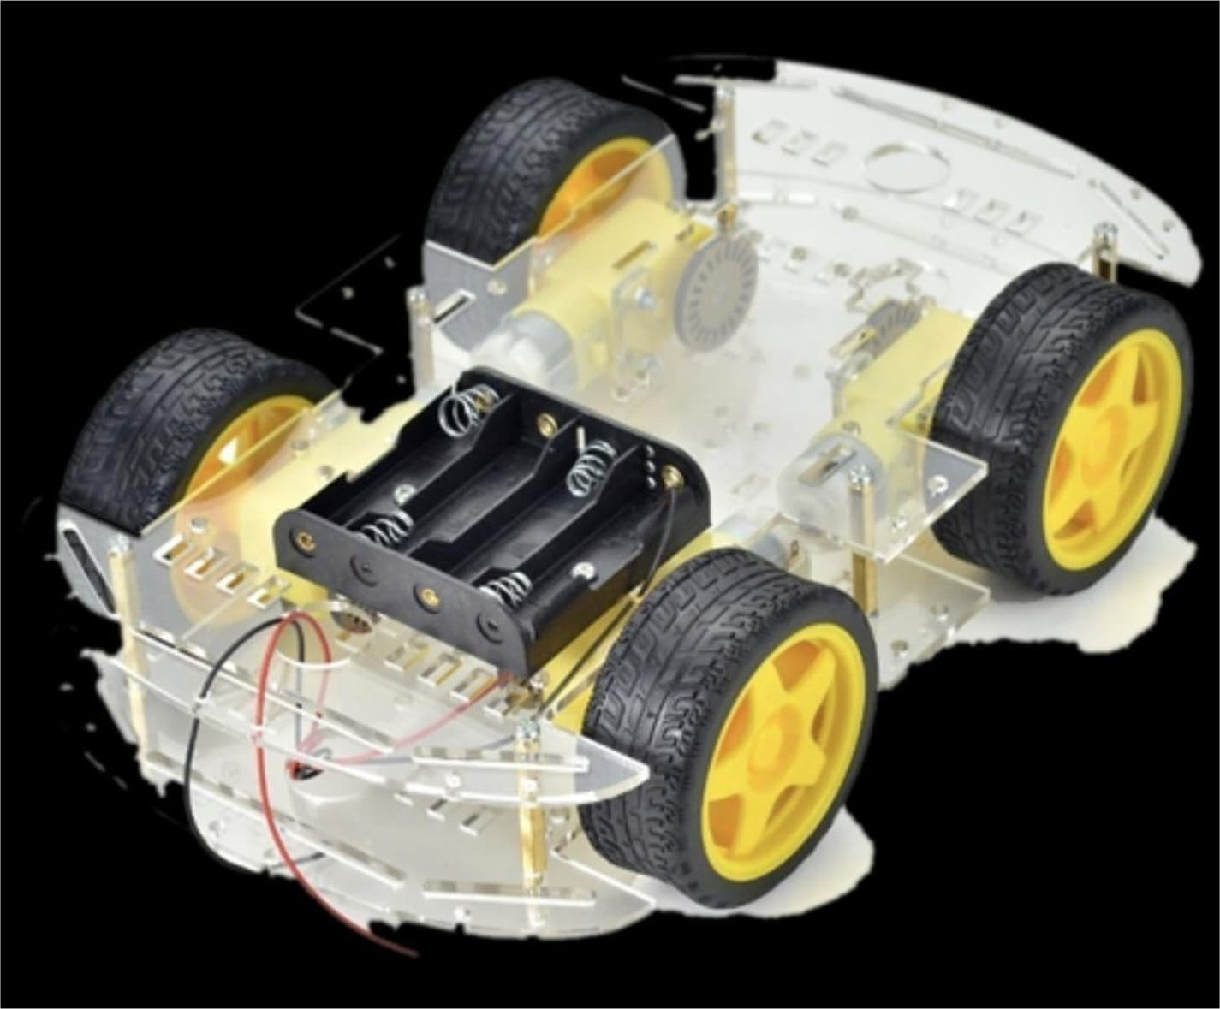

3. Circuit Diagram and Connections
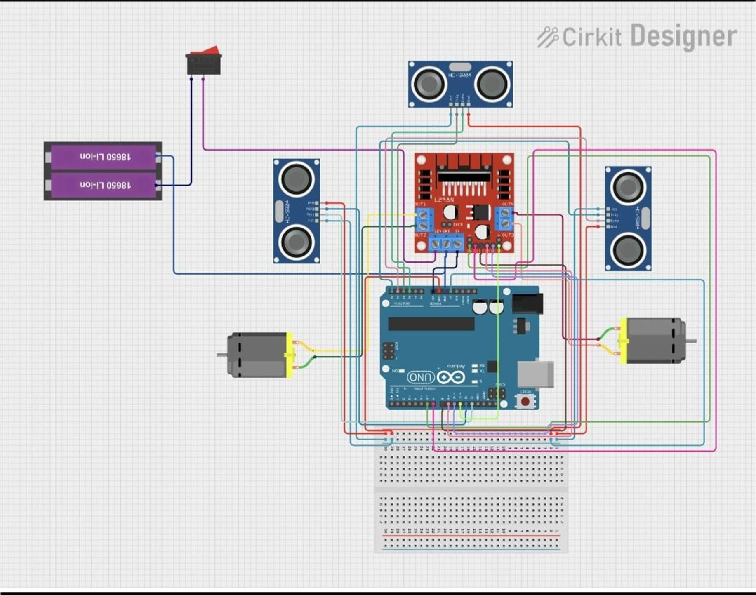
Based on the Cirklt Designer schematic provided, here is how the system is wired:
Power Connections:
Battery Positive (+) connects to a Switch, then to the +12V terminal on the L298N.
Battery Negative (-) connects to the GND terminal on the L298N.
L298N +5V terminal connects to the 5V pin on the Arduino (this powers the Arduino).
L298N GND terminal connects to an Arduino GND pin.
Arduino 5V and GND are connected to the breadboard's power rails to power the three HCSR04 sensors.
Motor Connections (L298N to Motors):
OUTI & OUT2: Connected to the Left side motors.
OUT3 & OUT4: Connected to the Right side motors.
Logic Connections (Arduino to L298N):
INI to Arduino Digital Pin 8
IN2 to Arduino Digital Pin 9
IN3 to Arduino Digital Pin 10
IN4 to Arduino Digital Pin 11
Sensor Connections (Arduino to HC-SR04):
Front Sensor: Trig to Pin 6, Echo to Pin 7
Left Sensor: Trig to Pin 2, Echo to Pin 3
Right Sensor: Trig to Pin 4, Echo to Pin 5

4. Working Principle
Scanning: The Arduino constantly triggers all three ultrasonic sensors to measure the distance in front of, to the left of, and to the right of the car.
Decision Making:
If the Front path is clear (distance > 20 cm), the Arduino tells the L298N to spin both motors forward.
If an obstacle is detected in front (distance < 20 cm), the car stops.
The Arduino then compares the distances on the Left and Right.
If Left has more space than Right, it reverses the left motor and moves the right motor forward to execute a quick Left Turn.
If Right has more space, it executes a Right Turn.
If all sides are blocked, it reverses until it finds a clear path.

5. Arduino Code
Here is the complete Arduino C++ code tailored to the 3-sensor circuit diagram provided:
// --- Motor Control Pins (L298N) const int INI = 8; // Left Motor Forward const int IN2 = 9; // Left Motor Backward const int IN3 = 10; // Right Motor Forward const int IN4 = 11; // Right Motor Backward
// --- Ultrasonic Sensor Pins --// Front Sensor const int trigFront = 6; const int echoFront = 7; // Left Sensor const int trigLeft = 2; const int echoLeft = 3; // Right Sensor const int trigRight = 4; const int echoRight = 5;
// Variables to store distances long duration, distFront, distLeft, distRight; int safeDistance = 25; // Minimum safe distance in cm
void setup() {
Serial.begin(9600);
// Set Motor pins as OUTPUT pinMode(lN1, OUTPUT); pinMode(lN2, OUTPUT); pinMode(lN3, OUTPUT); pinMode(lN4, OUTPUT);
// Set Sensor pins pinMode(trigFront, OUTPUT); pinMode(echoFront, INPUT); pinMode(trigLeft, OUTPUT); pinMode(echoLeft, INPUT); pinMode(trigRight, OUTPUT); pinMode(echoRight, INPUT);
void loop() {
// Read all three sensors distFront = getDistance(trigFront, echoFront); distLeft = getDistance(trigLeft, echoLeft); distRight = getDistance(trigRight, echoRight);
// Logic for Path Finding if (distFront > safeDistance) { moveForward();
else { stopMotors(); delay(300); // Pause to evaluate
// Check which side has more space if (distLeft > distRight && distLeft > safeDistance) { turn Left(); delay(400); // Time taken to turn 90 degrees (adjust as needed)
else if (distRight > distLeft && distRight > safeDistance) { turnRight(); delay(400); // Time taken to turn 90 degrees
else {
// Dead end, move backward moveBackward(); delay(500); turnRight(); // Turn around delay(600);
delay(50); // Small delay for stability
// Function to calculate distance from an Ultrasonic Sensor long getDistance(int trigPin, int echoPin) { digitalWrite(trigPin, LOW); delayMicroseconds(2); digitalWrite(trigPin, HIGH); delayMicroseconds(10); digitalWrite(trigPin, LOW); duration = pulseln(echoPin, HIGH);
return duration * 0.034 / 2; // Convert to cm
// --- Movement Functions --void moveForward() { digitalWrite(lN1, HIGH); digitalWrite(lN2, LOW); digitalWrite(lN3, HIGH); digitalWrite(lN4, LOW);
void moveBackward() { digitalWrite(lN1, LOW); digitalWrite(lN2, HIGH); digitalWrite(lN3, LOW); digitalWrite(lN4, HIGH);
void turn Left() { digitalWrite(lN1, LOW); digitalWrite(lN2, HIGH); // Left moves back digitalWrite(lN3, HIGH); // Right moves forward digitalWrite(lN4, LOW);
void turnRight() {
digitalWrite(lN1, HIGH); // Left moves forward digitalWrite(lN2, LOW); digitalWrite(lN3, LOW); digitalWrite(lN4, HIGH); // Right moves back
void stopMotors() { digitalWrite(lN1, LOW); digitalWrite(lN2, LOW); digitalWrite(lN3, LOW); digitalWrite(lN4, LOW);

6. Conclusion
The Obstacle Avoiding Robot successfully demonstrates autonomous navigation by processing environmental data in real-time. By utilizing an array of three ultrasonic sensors, the vehicle minimizes blind spots, ensuring smooth and intelligent pathfinding. This system serves as an excellent foundation for more advanced robotics, which can be further upgraded with machine learning algorithms, GPS tracking, or camera-based computer vision.

